TamilNadu’s Health Centers Report

(For Covid-19)

Done by: Shreebuvan V

**Introduction:**

The present scenario of the outbreak of the COIVD-19 has led to a pandemic which none of us have never even imagined off. This situation has made it really hard for even many of the developed countries like US. It has also made a wild swipe in India as well with almost 10 lakhs+ cases at present and still counting. Tamilnadu has become the one of the most affected states in India with almost 150k+ cases. Although Tamilnadu govt. have taken many steps to bring this pandemic to a control, the population density has always been an alarming problem. Therefore, there is always a huge problem in bringing forth the isolation centers in the state and making this accessible to the masses is also a rising problem. The issues to be kept in mind for this is as follows:

* Centralized centers alone cannot do any good to the people as people from the other parts of the state will not be able to get in access to the facilities
* When the infected are to be taken to the hospitals there are chances that the attendees may get affected and the social distancing fact is taken for granted in a state like Tamilnadu.

So decentralized testing and isolation wards can be very useful for the govt. to both keep the pandemic under control as well as treat the infected with the best facilities available and this work would of great help to them.

**Data:**

I have surfed through the Internet and found out NRIOL website where anyone can get the split-up of the population and the area (in sq. km) of a given state, district-wise. The most important feature is that we get all the details in tabular for with the .asp file extension which is easier to play around with. The information in the website is as shown in the image below:

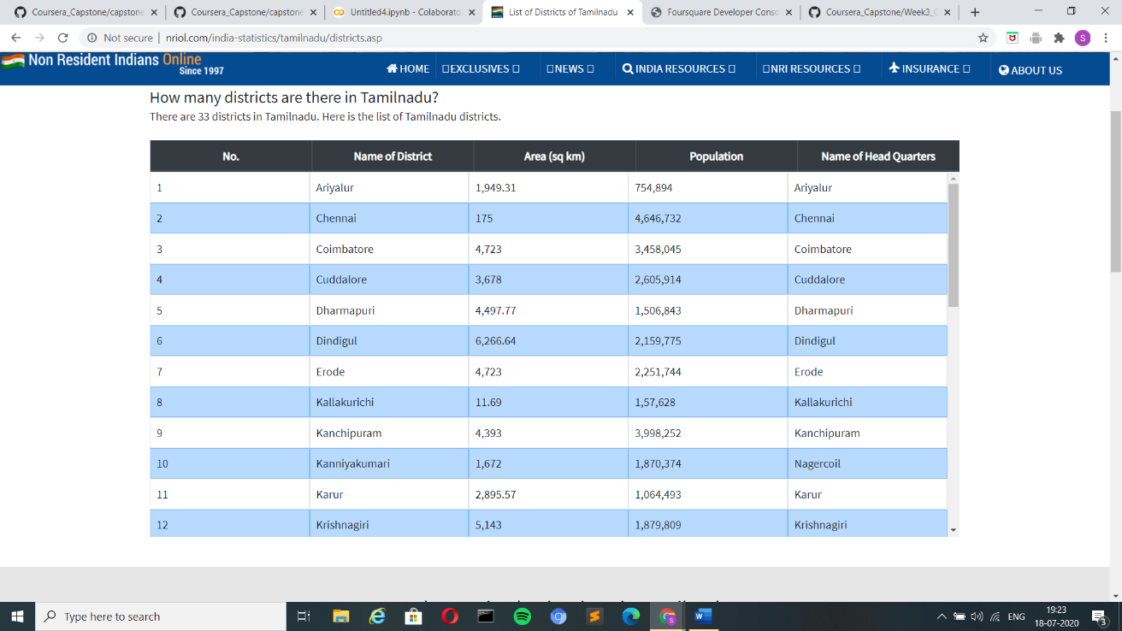

I have done the web-scrapping using the BeautifulSoup available as a part of the bs4 library in python. This information is then compiled and made into a dataframe and the latitude and longitude values where extracted using the Nominatim function in Geopy Library with the names of the districts which where web-scrapped from the NRIOL website. Now this information together makes the dataframe ready to play with and get the needed insights from it. The final dataframe with all the data values looks like the image below.

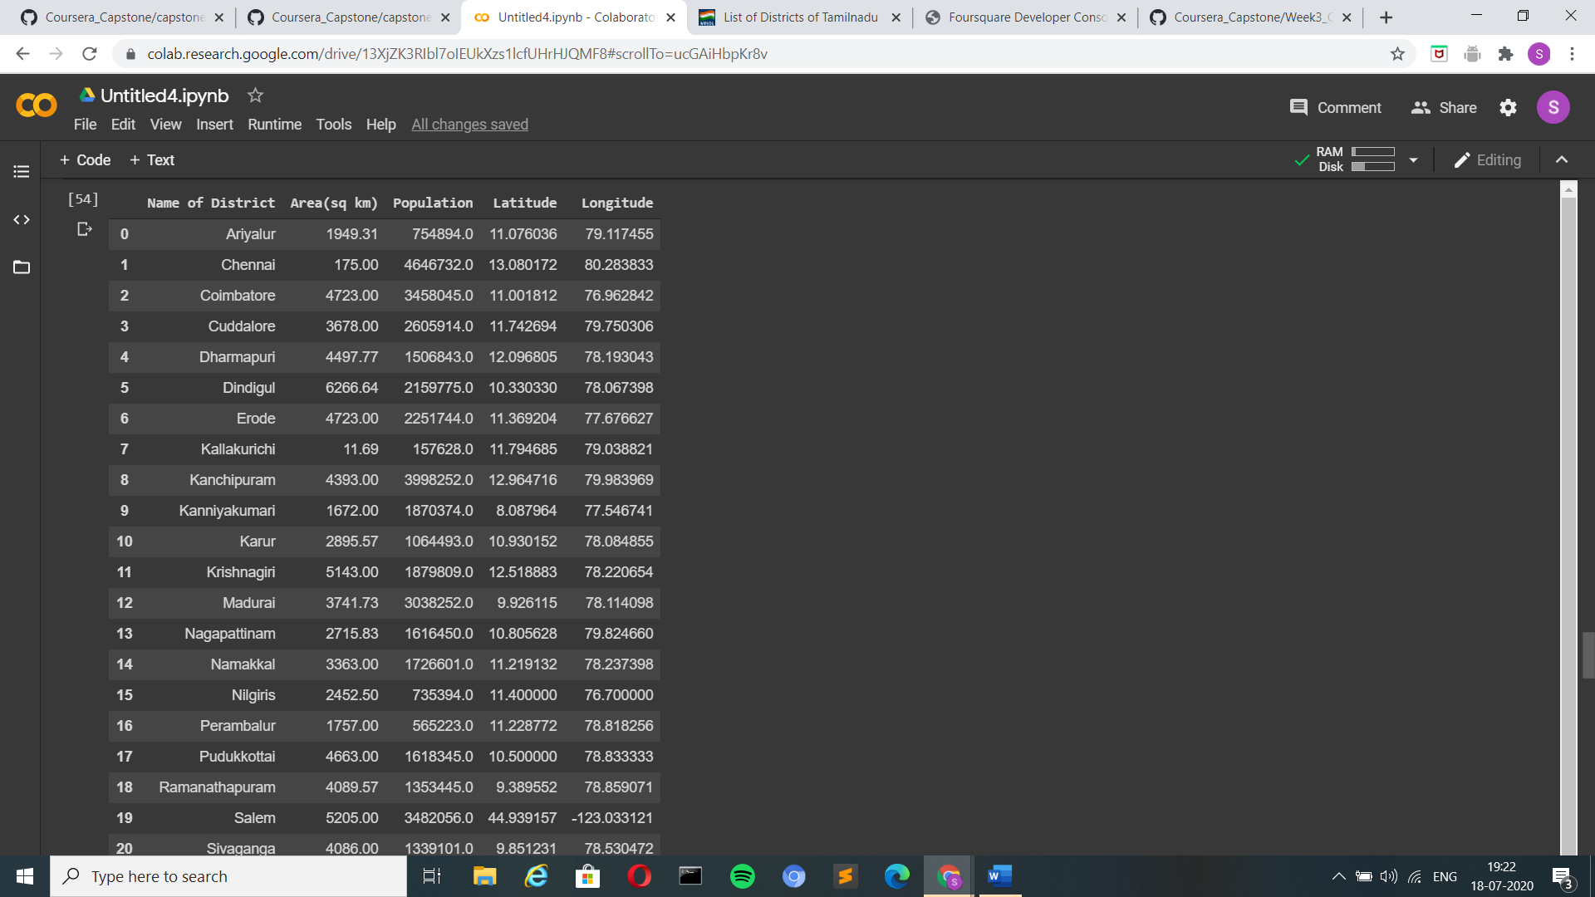

**Exploratory Data Analysis:**

The data from the NROIL website is scrapped and stored in three lists namely

District, Area and Population. Which is shown below.

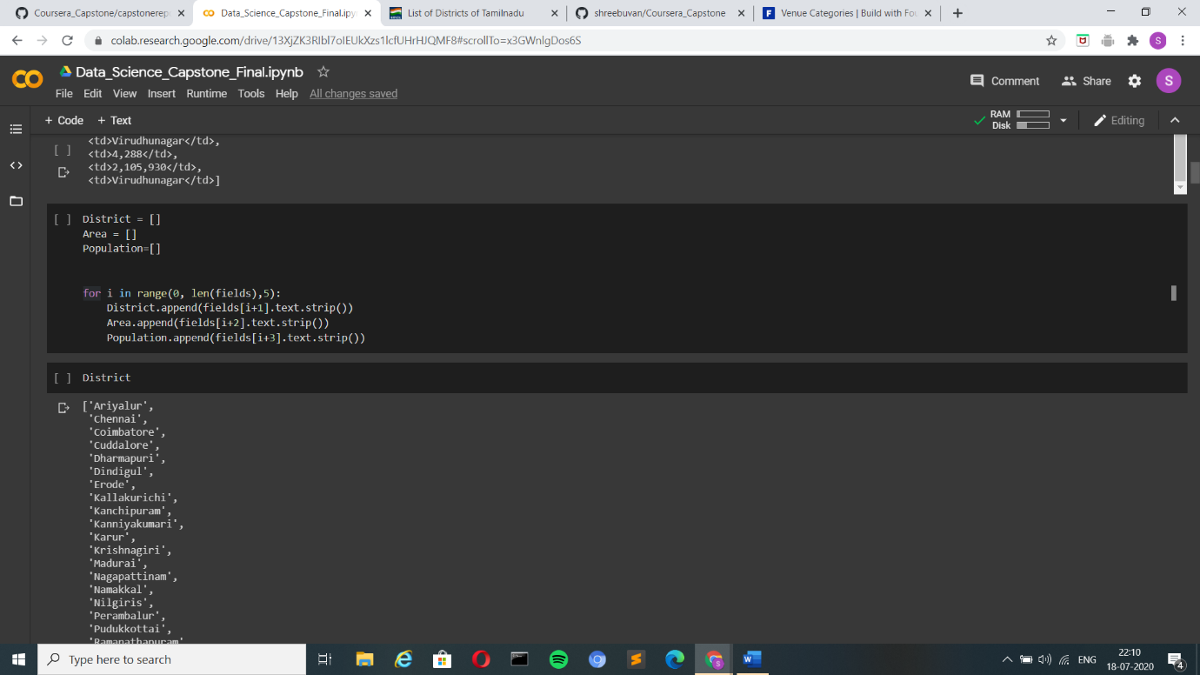

Next these three lists together form the intermediate dataframe as shown below 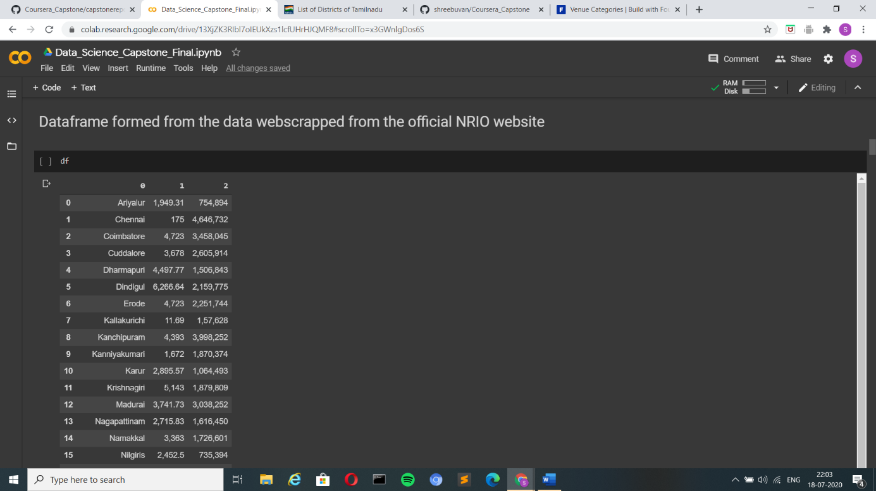

The area and population columns datatype are changed to float using the

astype() method and the comma’s in the numerical values are also removed using the replace() method.

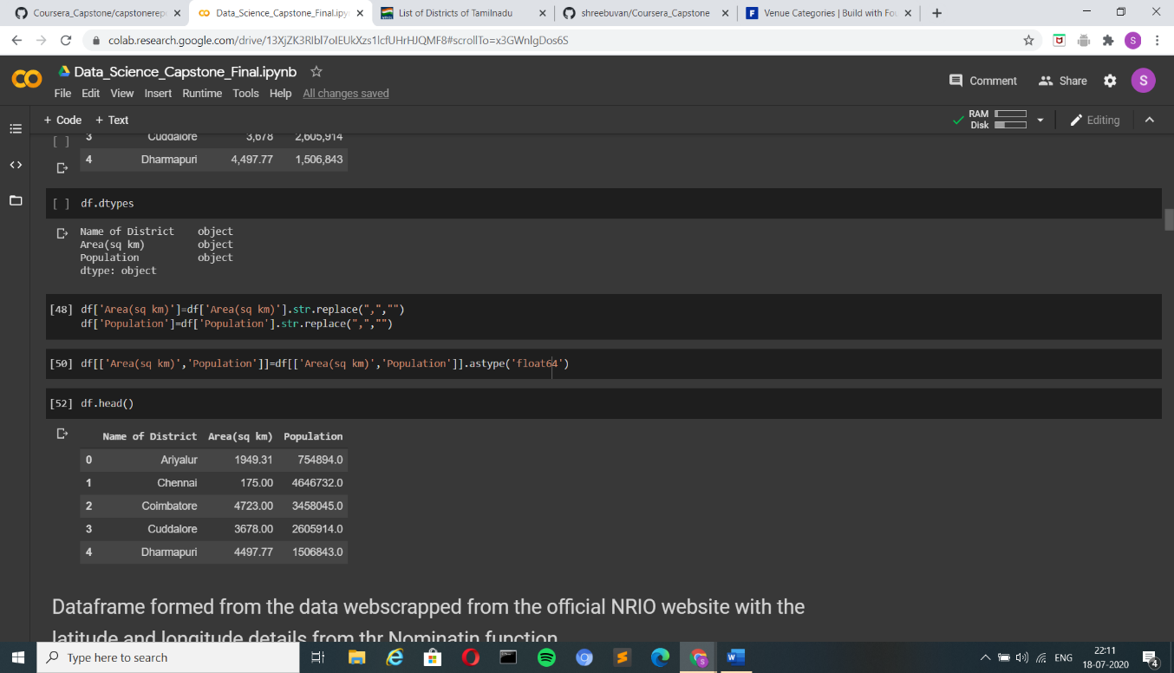

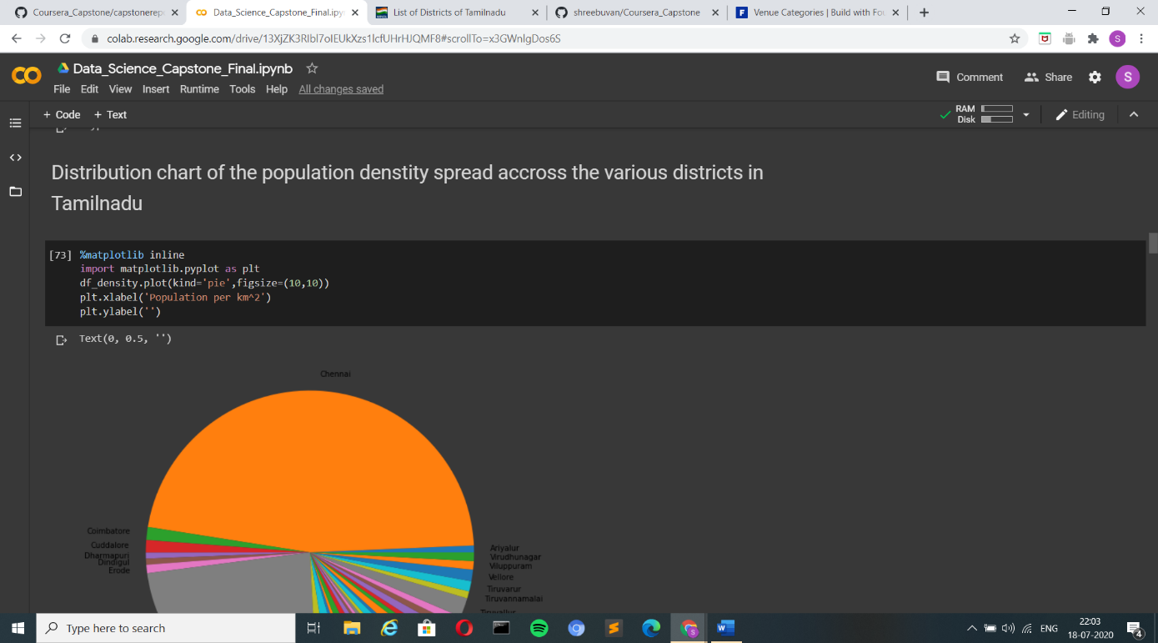

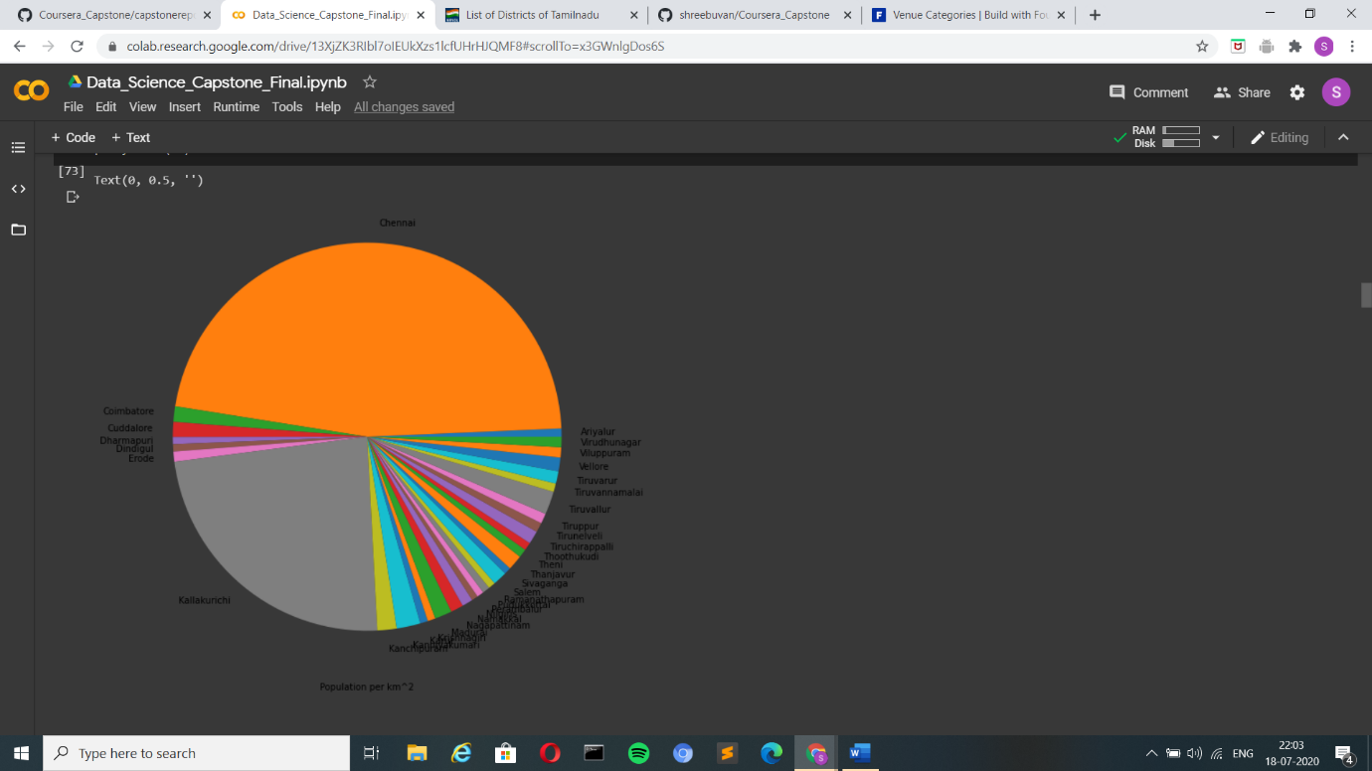

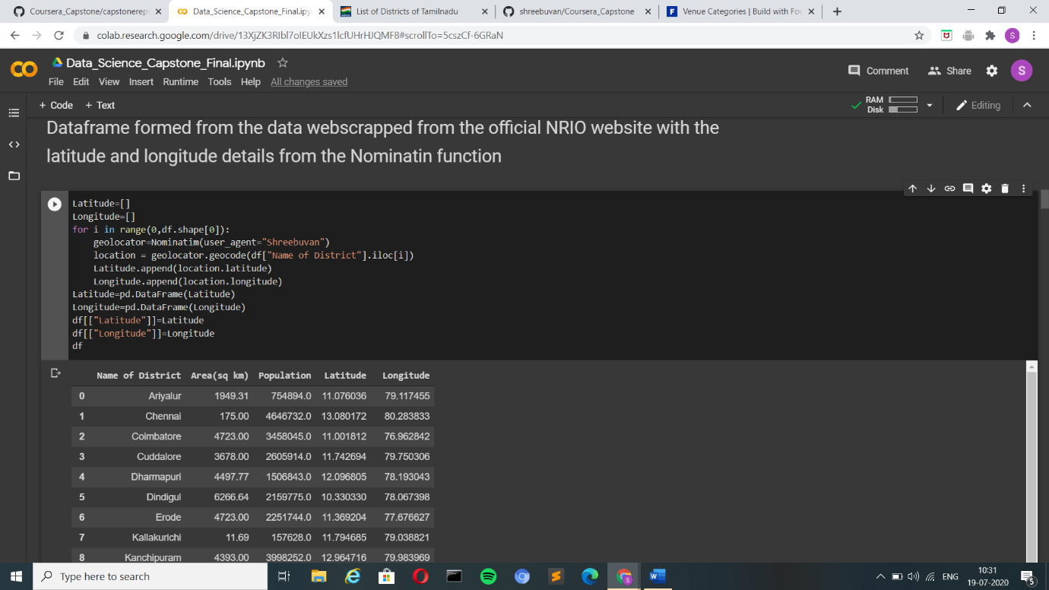

Figure: The population distribution in Tamilnadu (population/km^2)

Figure: Shows the final dataframe with the latitude and longitute of the different districts

**Methodology and Results:**

From all the analysis made, I have decided to get the individual details of all the nearby hospitals, medical supply centers, medical labs and emergency centers in Tamilnadu to a radius of 5000 set to the foursquare api call, then at last merge all the details and cluster them together to give an insight of the facilities that are available for the affected and most importantly, facilities closest to them.

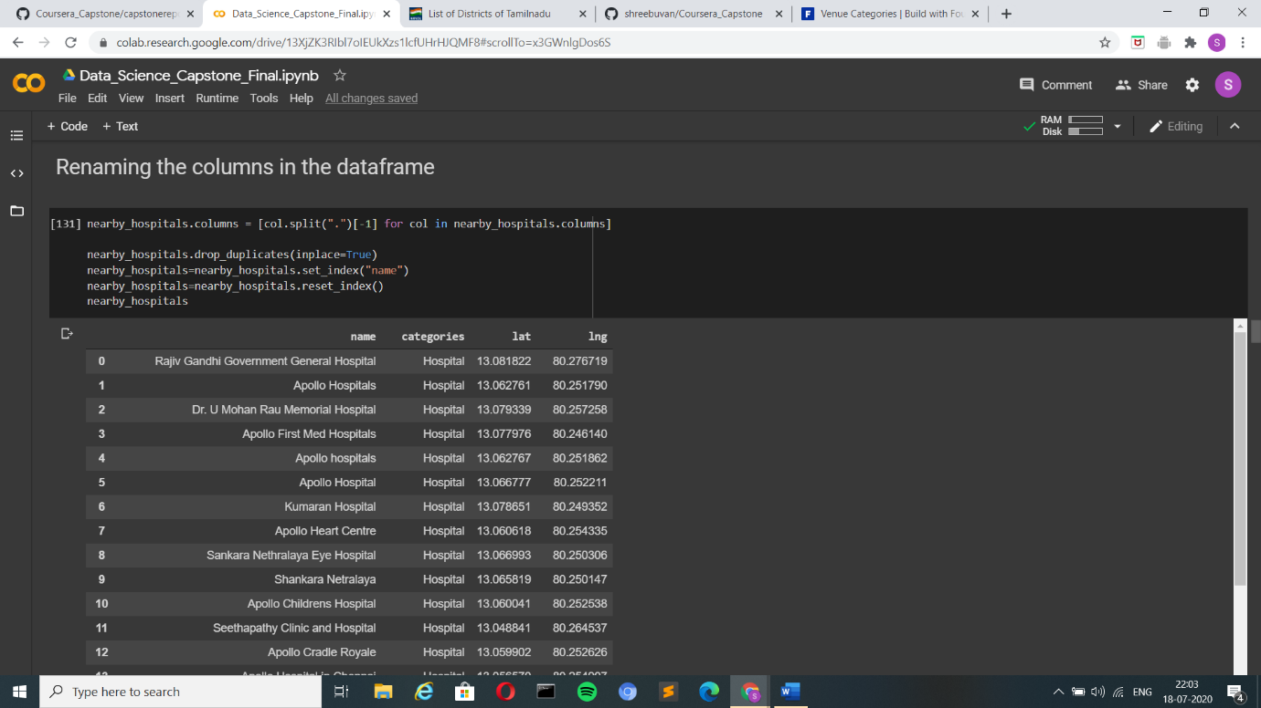 Figure: The details of the Hospitals retrieved from the foursquare api.

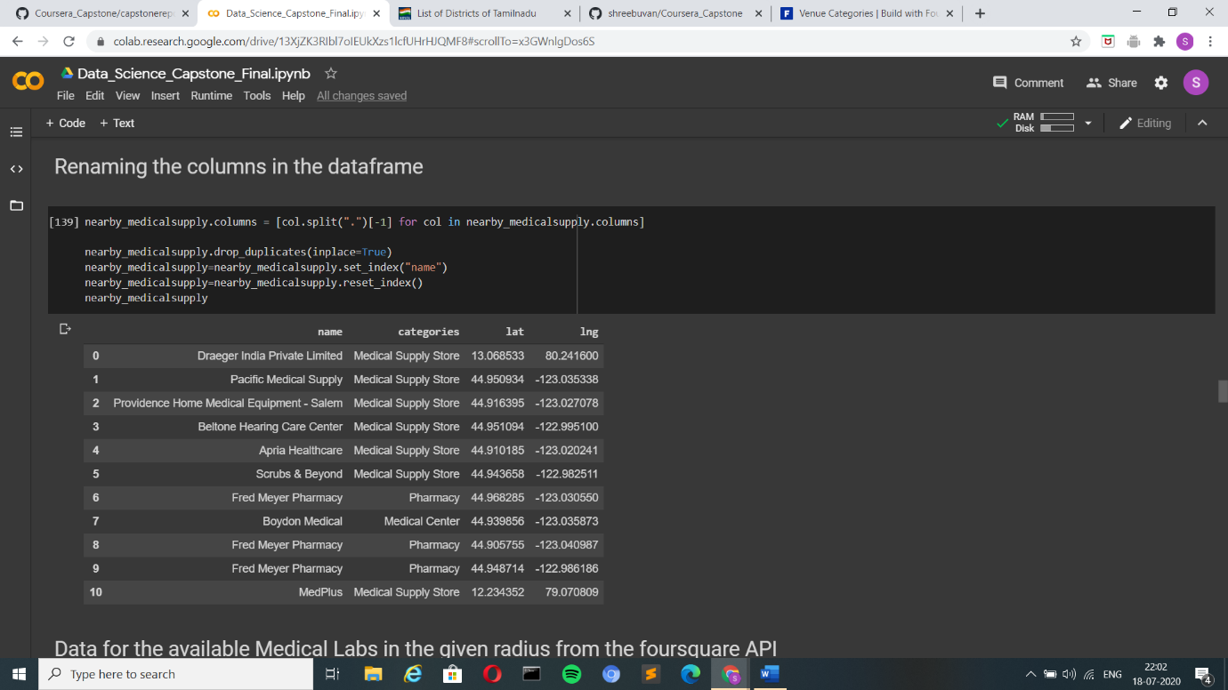

Figure: The details of the Medical Supply Centers from the foursquare api.

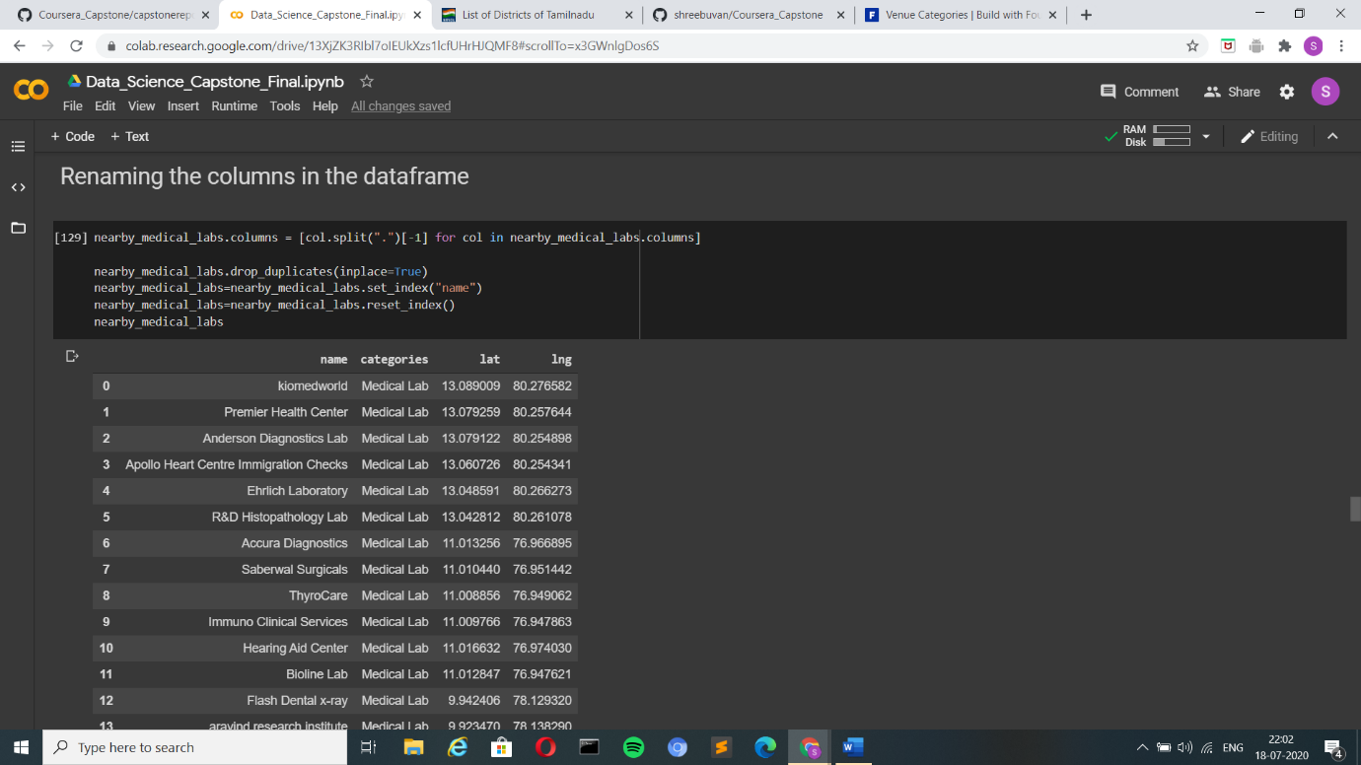

Figure: The details of the Medical Lab from the foursquare api.

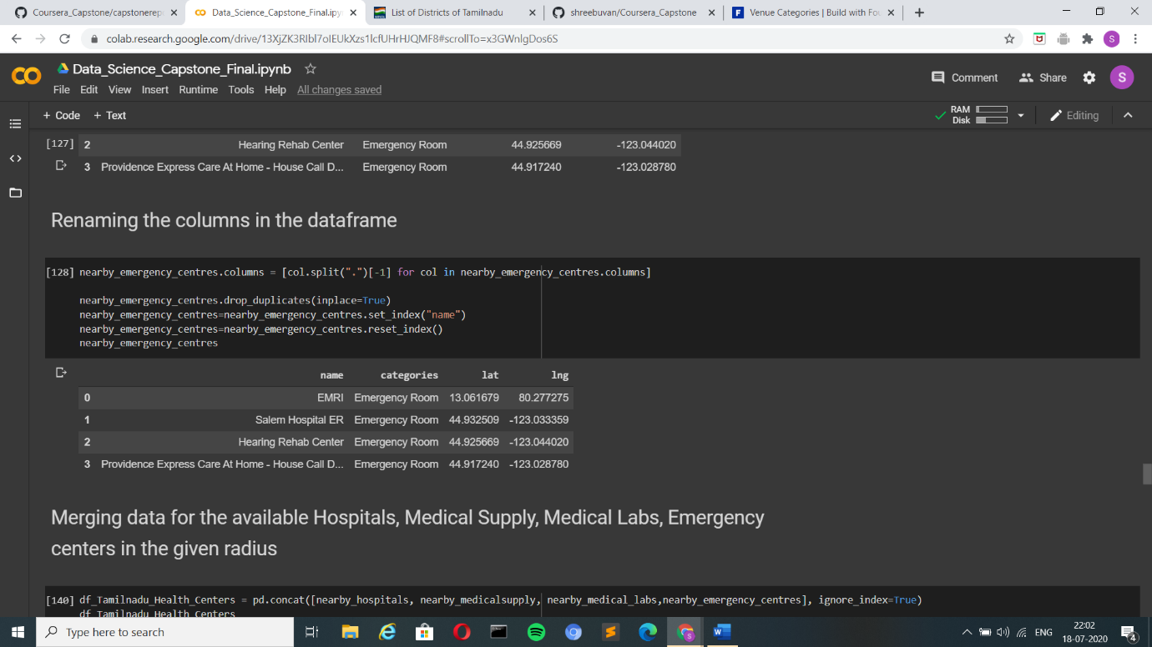

Figure: The details of the Emergency Centers from the foursquare api.

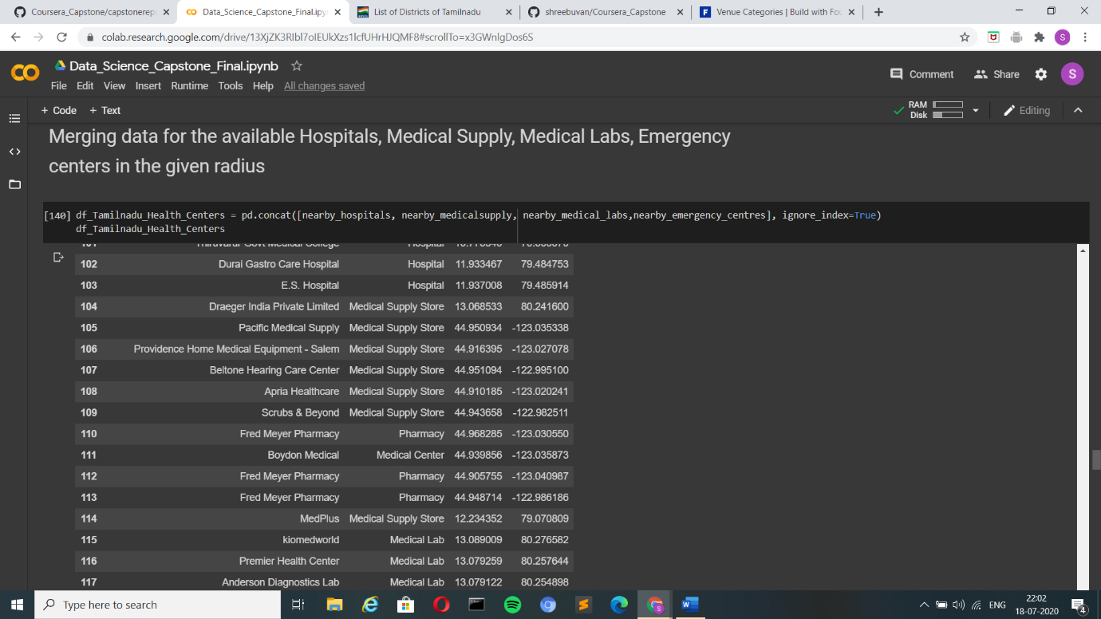

Figure: The details of the Hospitals, Medical Supply Centers, Medical Labs and Emergency Centers are all merged together.

Now that I am ready with the datails of all the facilities avalilable as a dataframe the next is to visualize all the facilities individually and collectively on the Tamilnadu map. I have done this using the folium.Map() function in the folium library in available in python.

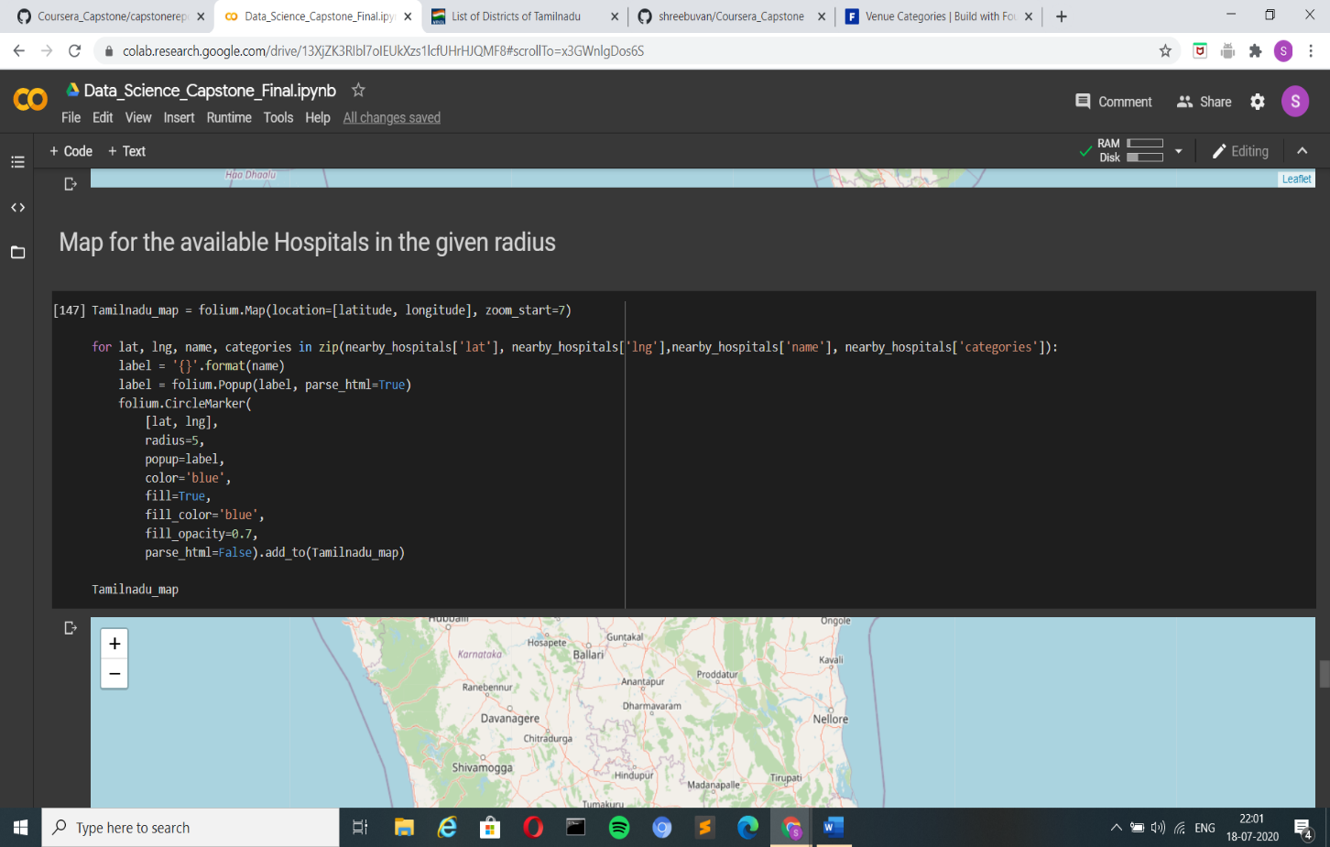

Figure: Passing the latitude and longitude values of Hospitals that should we marked.

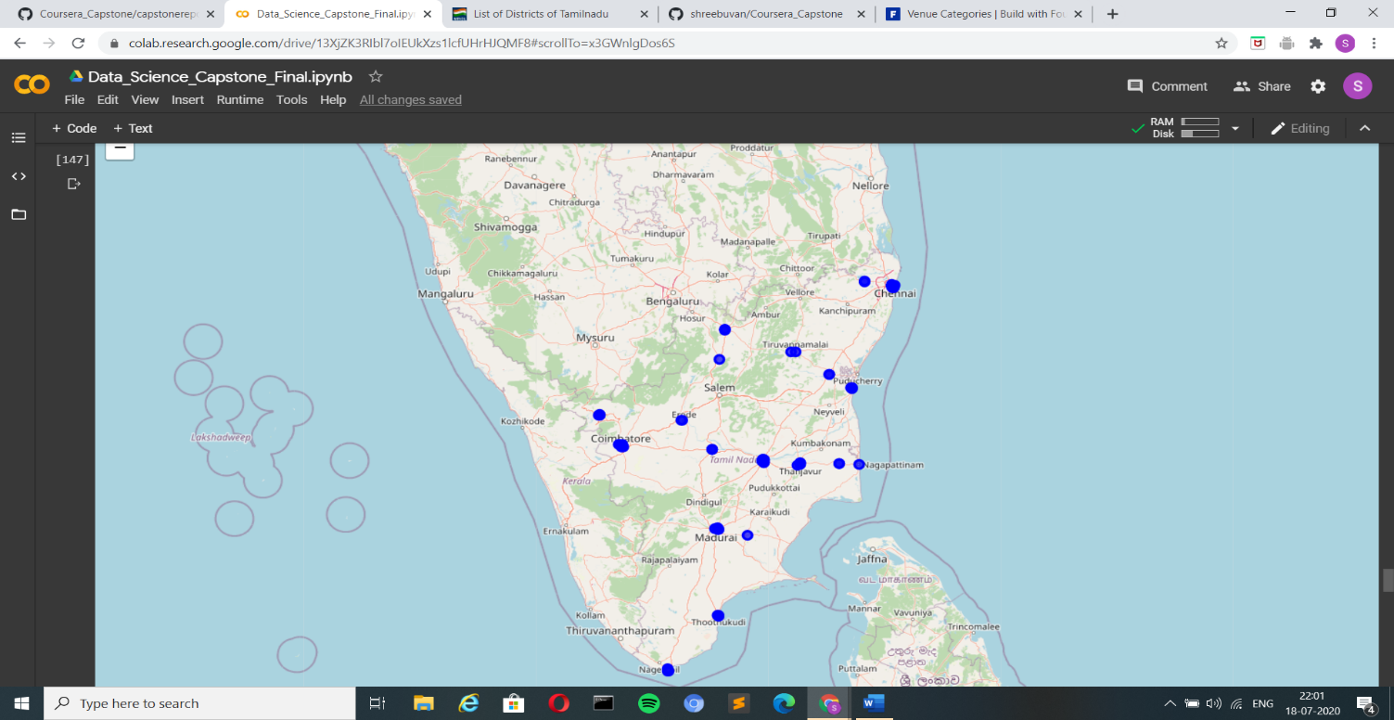

Figure: Map with the available hospitals marked on it.

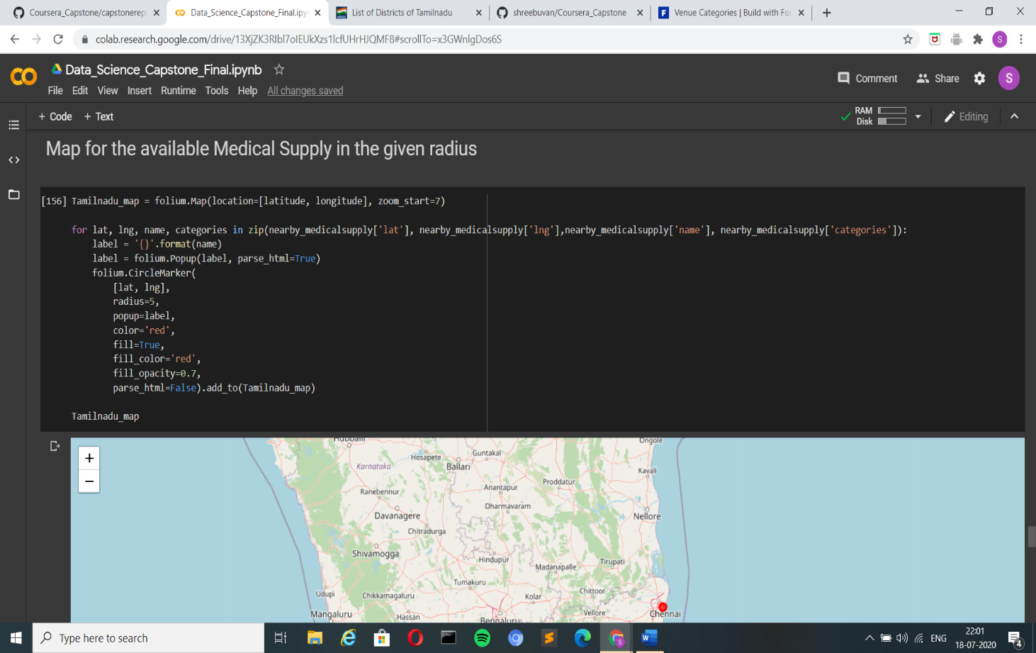

Figure: Passing the latitude and longitude values of Medical Supply that should we marked.

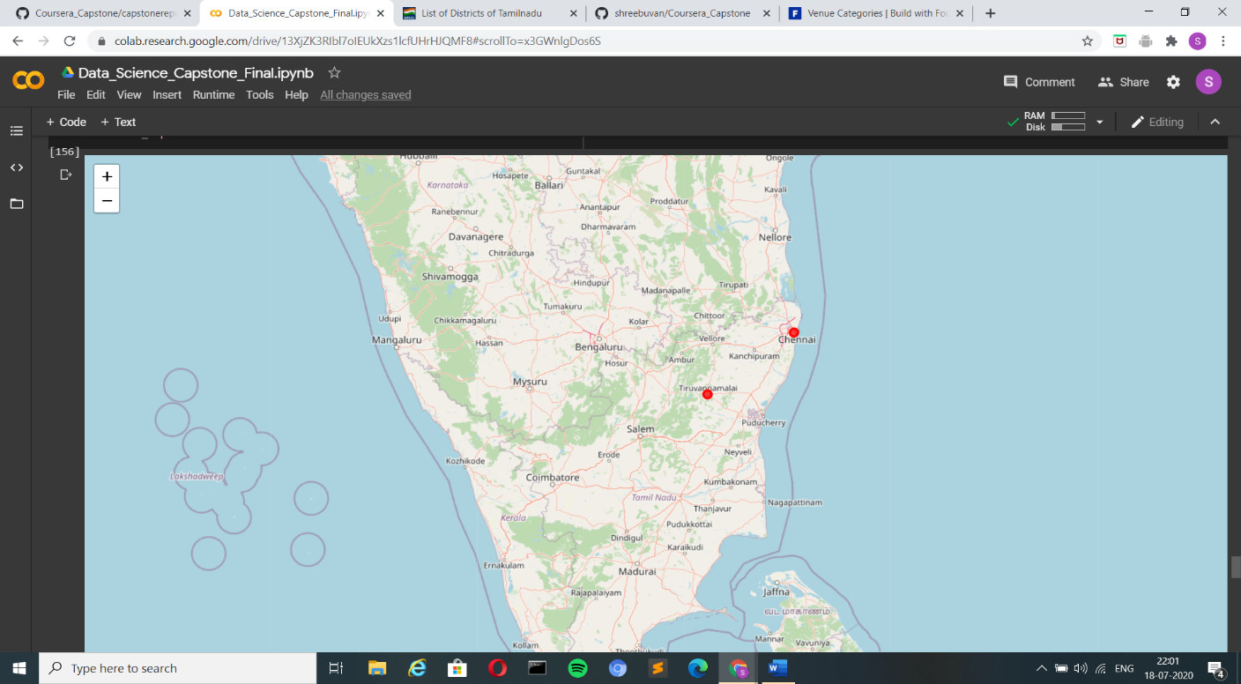

Figure: Map with the available Medical Supply Centers marked on it.

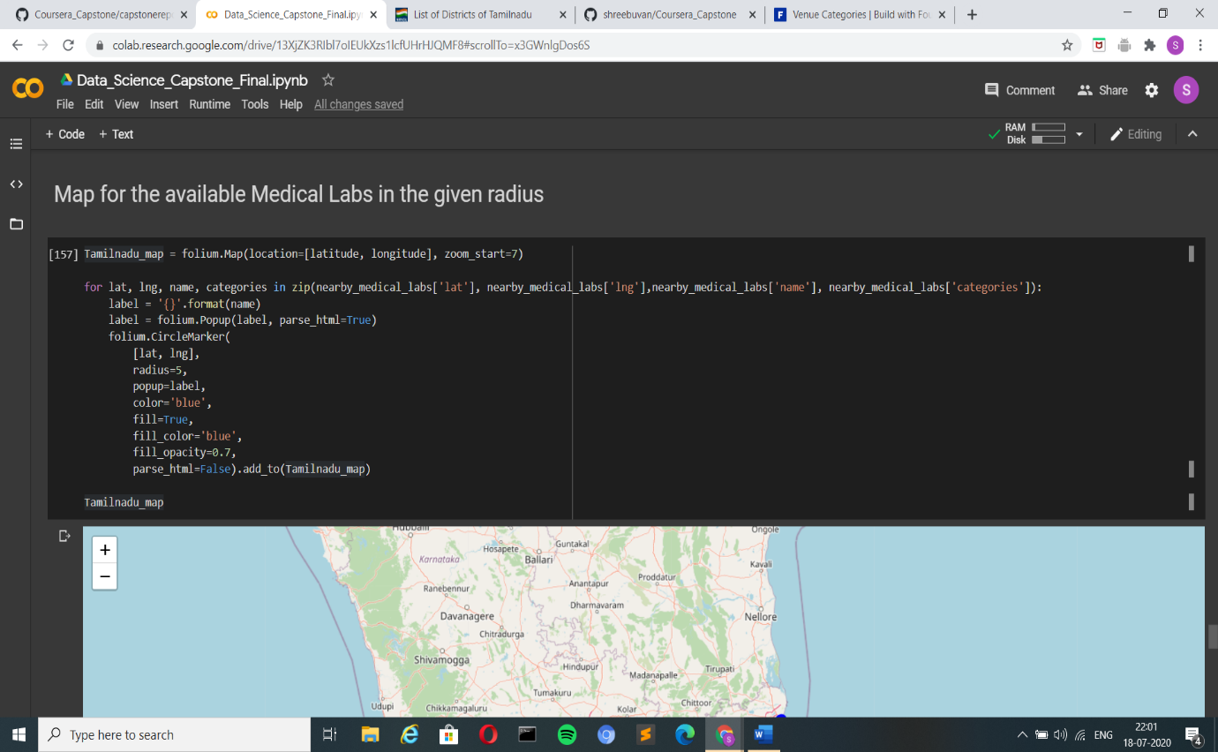

Figure: Passing the latitude and longitude values of Medical Labs that should we marked.

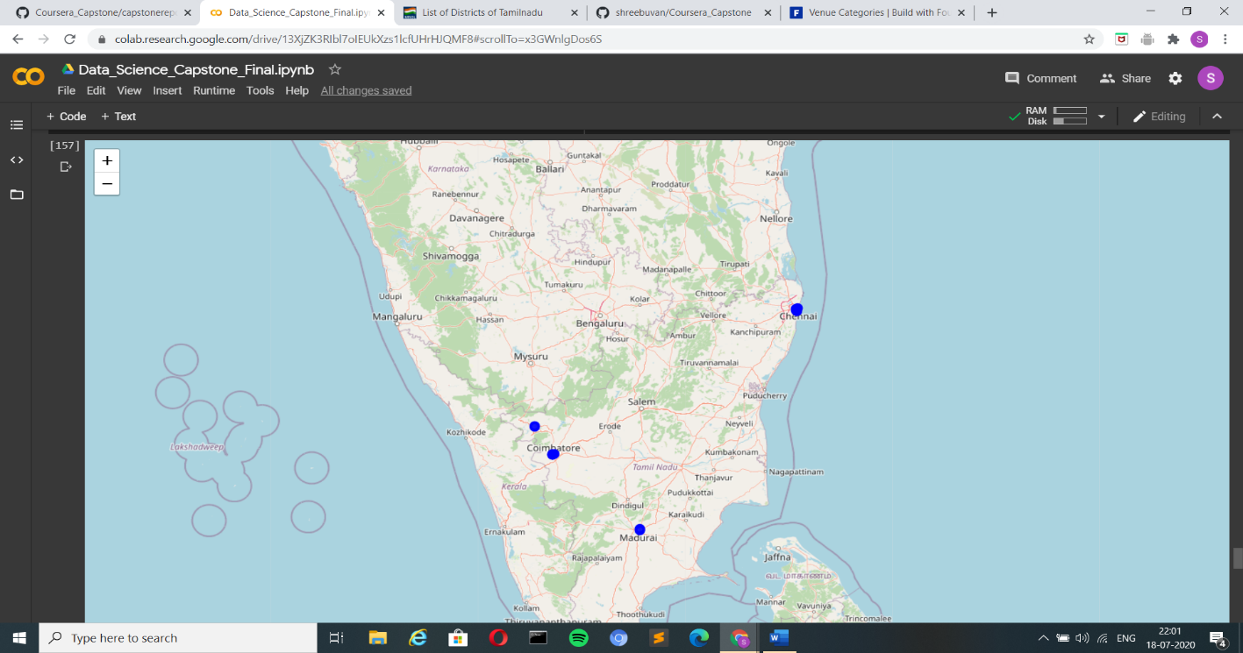

Figure: Map with the available Medical Supply Centers marked on it.

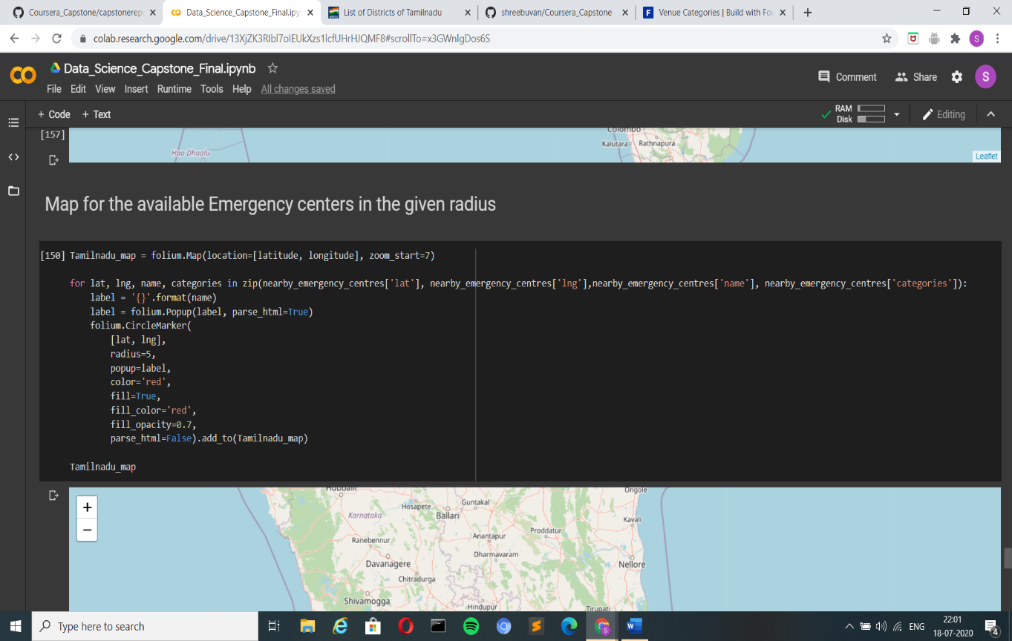

Figure: Passing the latitude, longitude values of Emergency centers that should we marked.

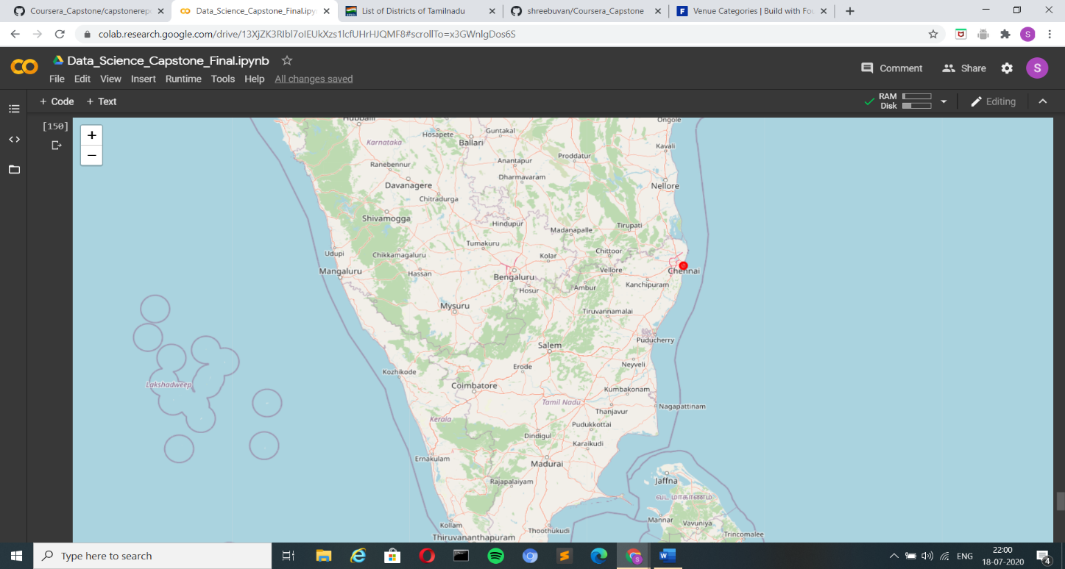

Figure: Map with the available Emergency Centers marked on it.

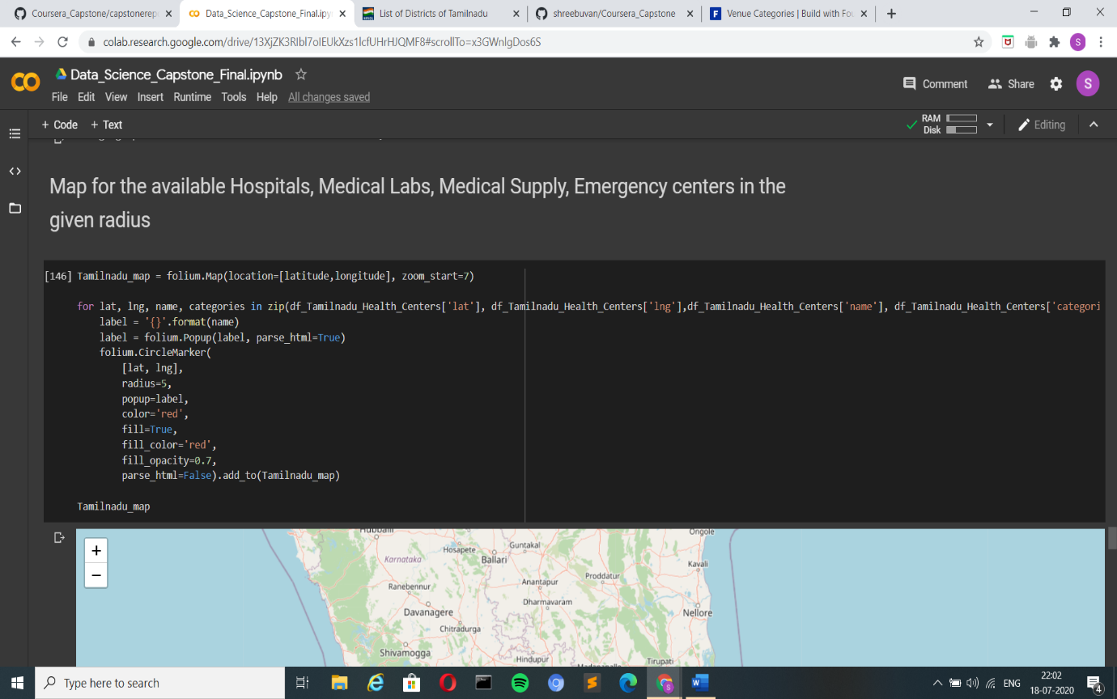

Figure: Passing the latitude, longitude values of all the four places that should we marked.

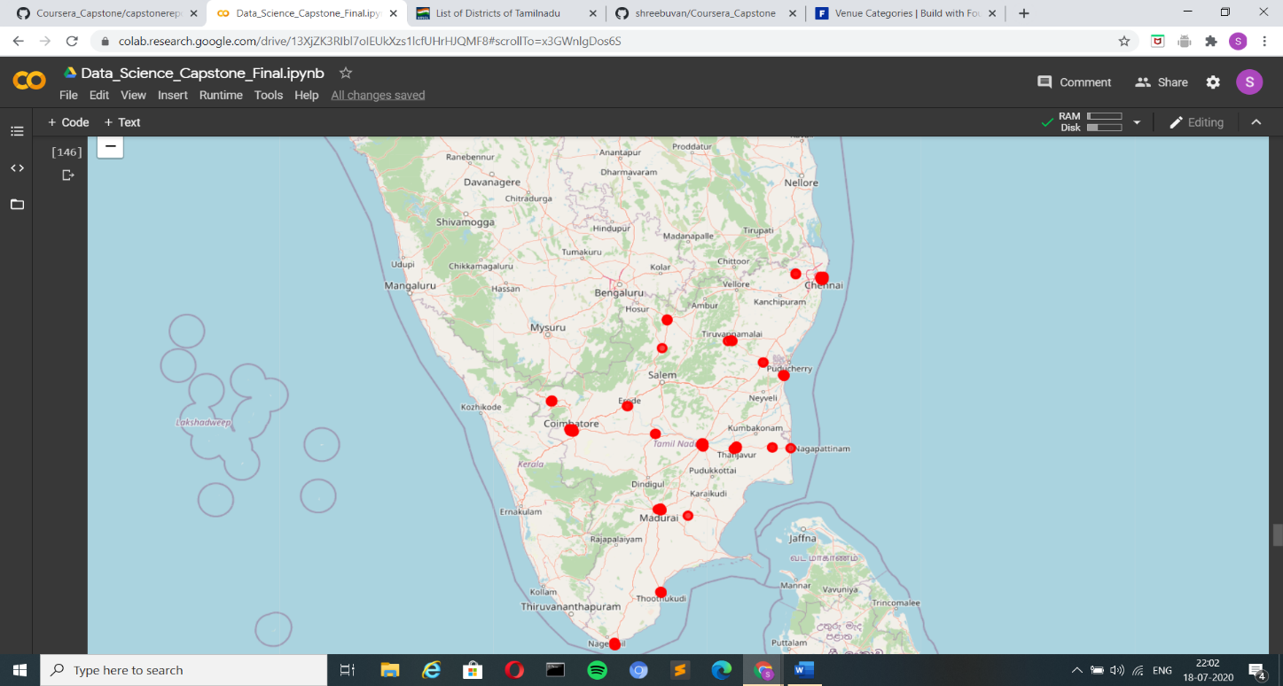

Figure: Map with the available Emergency Centers marked on it.

Now as we have seen from the trends above the facilities in not spread evenly across the whole state of Tamilnadu therefore, clustering this data will be a more feasibly option and this can we done using k-means algorithm and the value for k can be found out using the eblow curve. The elbow curve for this case looks like the one given below.

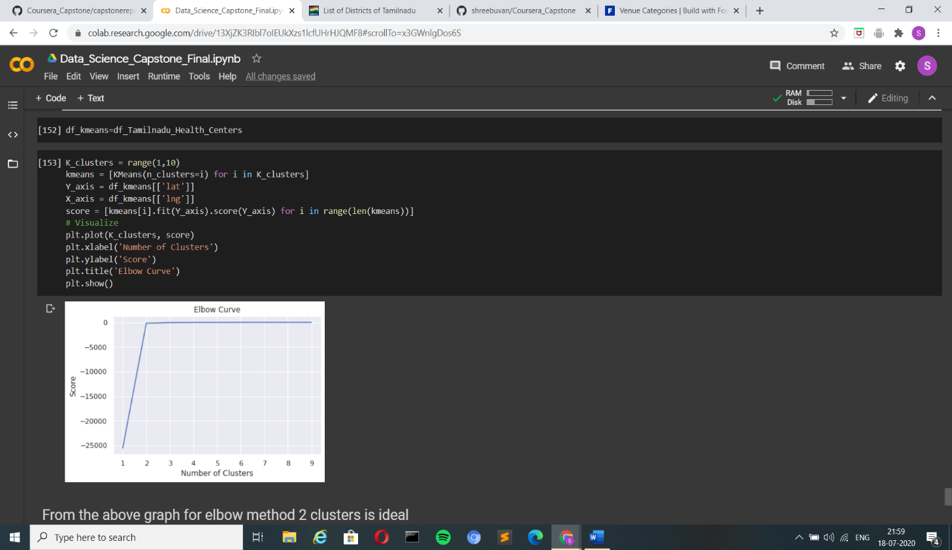**K-Means**

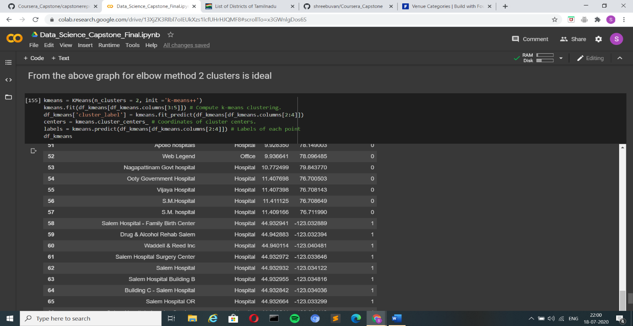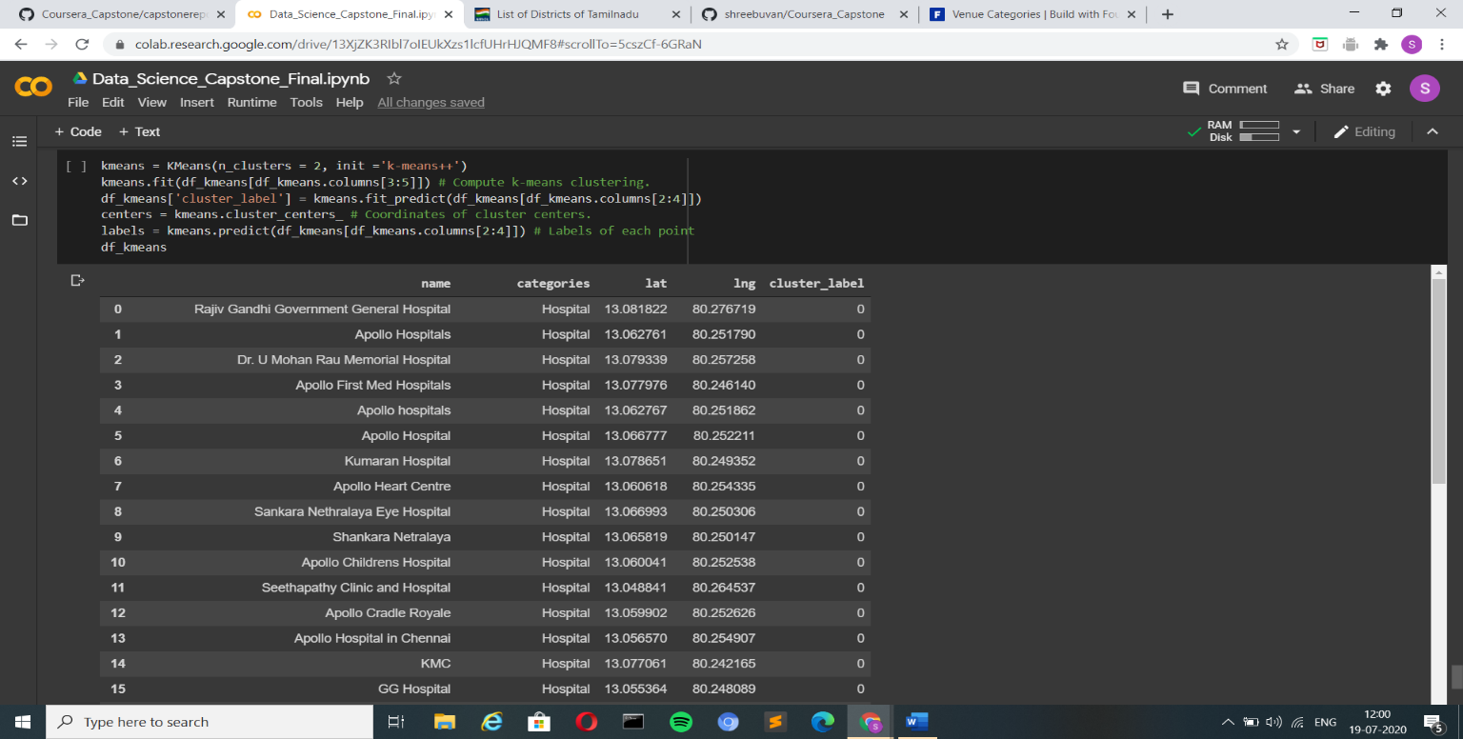The two images below show the final dataframe with the cluster lable for each of the four available facilities in Tamilnadu and as to which will we the most feasible and the nearest option for the affected patients.

**Discussion:**

* As we have seen so far, I have taken the problem the medical amenities not being made available to everyone in this pandemic situation.
* I have made a study of all the facilities that are available in the state as a whole and made a visualization of it which will give an insight on which are the parts of the state where these facilities are available/not available.
* From this the government can take in steps to improve the facilities in the regions of the state where there are limited facilities and improve the present status of the medical support in those places which are deprived of it.

**Conclusion:**

* To improve this situation of the decentralized people getting deprived of the facilities can we minimized by seeing this study and bringing in temporary medical camps in the places where people are not able to gain access to the medical facilities.
* Now it is up to the government to step up and take a move in bringing a change to this current situation that is prevailing.
* I really hope that this study can help in making the basic medical facilities made available to all the people during this difficult phase of pandemic that we are going through right now.